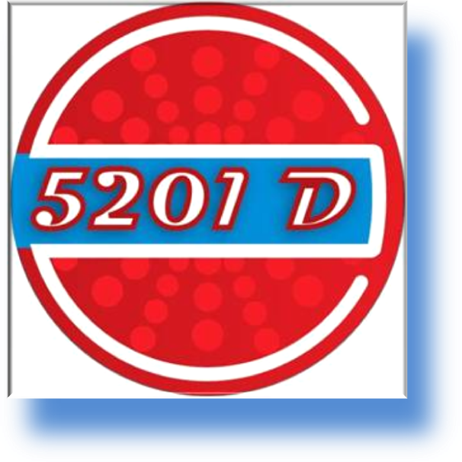

BY

N.Y.E. sarl

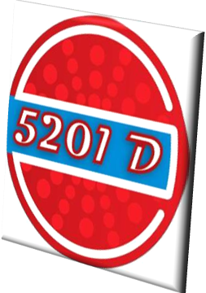
Overview

N.Y.E. is part of an international network of companies, laboratories and enthusiasts in the field of alternative energy and fuel additives.

Our main concerns are to optimize the utilization of the current fuel sources and to develop other alternative sources to help in the process of protecting the environment and public health.

All our products are specifically designed for the local markets. It is manufactured under strict quality controlled conditions. As it is widely known, the characteristics and properties of fuels sold in Lebanon are very different from those found in Europe, or other Western countries. This can be noticed once you buy a used car coming from those countries. You will notice that the mileage will decrease progressively from the time you buy it onwards. This is due to the fact that our fuel lacks some basic additives that are already found in western countries’ fuels that aim at optimizing combustion and decreasing emissions.

The 5201 series of fuel additives that we produce come to fill the gap and to help improve the quality of the fuels found in Lebanon so that we will achieve the maximum efficiency possible out of it.

The 5201D caters for diesel needs. It is the most efficient fuel additive found on the market today. It cleans, maintains and protects the whole parts of the fuel system as well as optimizes combustion and above all, it decreases consumption substantially.

There is no additive in the world that can decrease consumption by more than 3%. 5201D has gone miles beyond that figure.

With its mixing ratio of just 0.2%, one can rest assured that it will not harm the engine by any means. Even if this quantity is just water, it will not produce any damage. This liquid is a mixture of non-harmful, combustible components that aims at two things:

- Improve the quality of diesel

- Improve the efficiency of the combustion process

For best results, the additive should be used in the proper dosage (allowed error is ±5%) and on a regular basis with each refill. This will ensure that the engine / equipment will entertain all the benefits at all times.

5201D is the only fuel additive in Lebanon that:

- Decreases diesel consumption significantly
- Is not harmful to the engine
- Provides many other benefits which you cannot get from just one additive in the local market
- Is promoted in a way where the end-users will test and be convinced in the results by themselves

5201D fuel additive improves the performance of:

- Diesel engines in any vehicle or machine
- Diesel gen-sets whatever their age or type is
- Boilers of all types

5201D fuel additive has more benefits such as:

 |  | Before | After
1 | Cleaner fuel lines
2 | Cleaner injectors | 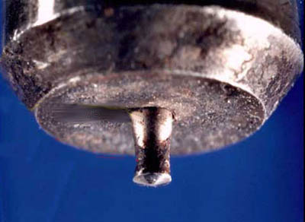 | 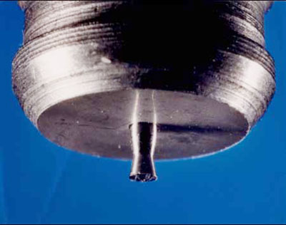
3 | Water removal
4 | Less smoke | 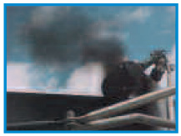 | 
5 | Lower emissions
6 | Better combustion | 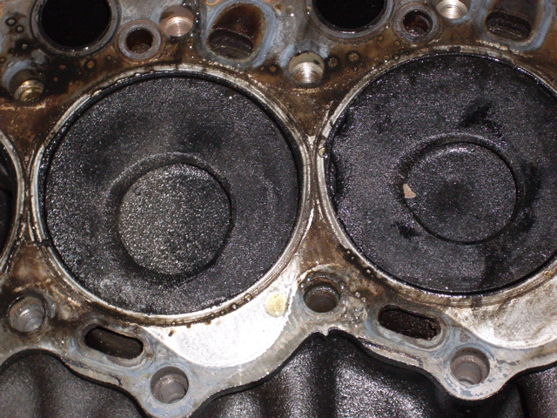 | 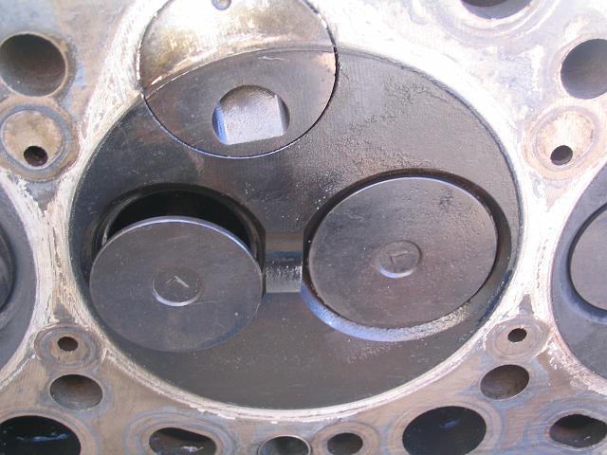
5201D fuel additive can be used with:

- Low sulfur local green diesel (sulfur <0.01%, low olefin and aromatic content)
- Local red diesel (sulfur <0.5%, medium olefin and aromatic contents)
- Other dirtier types of diesel (sulfur > 0.5%, higher impurities, olefin and aromatic contents)
- Biodiesel

5201D fuel additive is safe to be used with:

- Catalytic converters
- Exhaust particulate filters

How does it work?

Fuel combustion in an engine is a very complex and instantaneous reaction. Minute changes in the fuel structure can influence the characteristics and performance of the fuel. Altering the surface tension and the molecule size of the fuel has significant effect on the way the fuel is atomized and burnt in the compression chamber.

5201D modifies the combustion process to make it more efficient. In the figure below you find consecutive frames of the combustion process taken from the initial spark. Using 5201D the combustion process will move directly from the first frame (-5) to the one in the frame showing (+10) without passing through the frames (-3) and (0). The ignition will take place almost instantaneously in the whole cylinder and not progressively from the top to the bottom. This is done because 5201D decreases the surface tension among the diesel molecules once compressed in the cylinder. Doing this, the spark will progress among the diesel-air mixture much faster. This situation should not be confused with “auto-ignition” where the diesel-air mixture ignites before the piston cycle covers the desired distance.

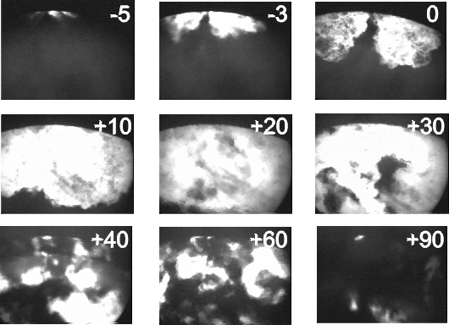

5201D works like a detergent. It removes carbon and other deposits from the fuel line, injectors and cylinders and keeps it clean. Once used for the first time, you may notice some black smoke initially which is the result of cleaning the fuel system. This smoke will vanish after few minutes depending on the volume of deposits to be removed. Continuous use will ensure cleaner fuel lines, injectors and cylinders. In addition, it emulsifies water present in the diesel and pushes it directly to the separator.
The 5201D Formula Tackles All Diesel Problems Such As:

Cold weather protection: reduces diesel pour point by up to 20 °C

Hot weather protection: lubricants and cetane improver helps when the diesel is hot and thin

Increases horsepower: by up to 8% (this is relative to the actual horsepower not the rated one)

Reduces fuel consumption: depending on the diesel type, the average reduction percentage is as follows:

- 10-15% for local green diesel (sulfur <0.01%, low olefin and aromatic content)
- 15-25% for local red diesel (sulfur <0.5%, medium olefin and aromatic contents)
- > 25% for other dirtier diesel in the market (sulfur > 0.5%, higher impurities, olefin and aromatic contents)
- 10% for biodiesel

N.B. Figures variation depend on the status of the engine/ equipment under treatment and the diesel actual quality as well as the accuracy of the measuring instruments

Better starting: in all conditions

Reduces smoke and emissions: in all types of diesel. As the diesel gets dirtier, the result becomes more noticeable

Cleans and protects: detergents and deposit modifiers help protect and clean the fuel line, injectors, nozzles, etc… from sludge, varnish and other contaminants

Reduces wear: its lubricity effect helps elongates the life of the various parts as well as the filters

Stabilizes fuel: antioxidants keeps fuel fresher

Removes water: it emulsifies water droplets found in the diesel and helps the filter/separator in catching it easier

Can be used with biodiesel: gives the same benefits with B20 blends or lower

Environmental Benefit

One of the greatest problems to the environment is air pollution coming from fuel combustion. The smoke and other hazardous particulates pose severe problems to the public health and the environment at the same time.

In Lebanon, this problem can be visibly noticed in large cities where the smog creates a cloud-like form that aims at suffocating the citizens with emissions. 5201D helps greatly in this regard by targeting several points at once:

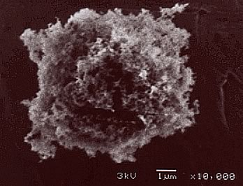
- Decreases diesel consumption: less consumption means less emissions means less pollution

- Minimizes smoke: these hard particulates (pictured to the right) are one of the essential reasons in many cancerous diseases

- Lowers emissions: due to the better combustion efficiency, these toxic emissions will be reduced by up to 45%

Composition:
5201D is made of Ketones, hydrocarbons, IPA, petroleum based oil and the 5201 additive package

Physical Data:

Melting Point | -85 °C
Boiling point | >120 °C
Flash point | 65 °C
Specific Gravity | 0.84 – 0.88
Solubility in Diesel | 100% soluble
Stability | Highly stable

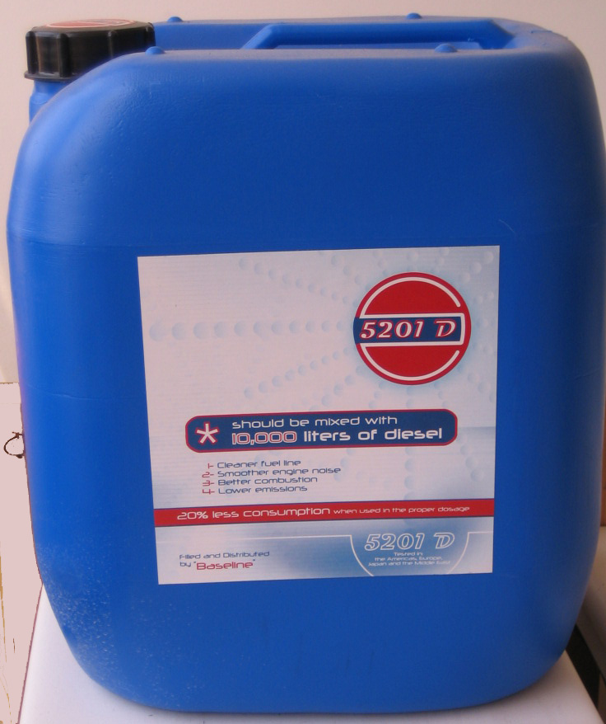
Delivery:

The additive is currently being packaged in 20 liters special plastic containers. Sample is shown to the left.

Usage:

The additive should be used in the proper dosage which is 0.2%. It can be added directly to the diesel without any special mechanism or technique. Mixing will take place in less than 10 minutes.

Storage:

If received in bulk and not in the standard 20 liter containers, storage should be in closed dark containers preferably in the shades at ambient temperature. Transparent containers of any type are NOT recommended. Storing under direct sun light may cause the internal pressure to build up and burst the tank. Therefore, it is recommended to store in the shades.

Storage containers should be well sealed since leakage to the atmosphere for several hours may cause the dosage proportion to change which may lead to a decrease in the additive efficiency.

Precautions and Personal Protection:

- In case of eye contact, wash thoroughly with a lot of water for at least 10 minutes.
- In case of skin contact, wash with water and soap
- Do not spill on paint, colors may fade
- Do not inhale
- In case of any kind or irritation, please consult a physician immediately

Tests

Cleaning Test

As shown in the figures below, one will notice the difference resulting from using the 5201D additive with the diesel or using a bad quality fuel. These pictures were taken from a power generation plant of a medium sized factory. This plant has 3 similar generators and the additive was used for one generator only. These images were taken after 2 months of continuous usage.

This is taken from a generator using non-treated diesel. You can notice the sediments and oily substance sticking on the cylinders and pistons
This is the block cover showing the intake and exhaust valves of the generator that used diesel treated with 5201D additive
This is the tip of the injector showing also the nozzle in the generator using the non-treated diesel
This shows the same part but in the generator using the treated diesel

Exhaust Test

Same goes below where images of the exhaust of the two generators under comparison were taken. In other tests, toxic emissions were reduced by up to 45%.

Without the additive
With the additive

Performance Test

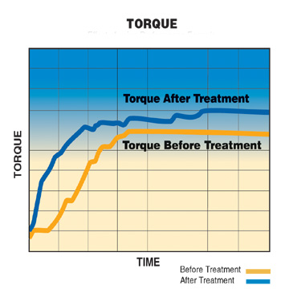
The results below were gathered from many tests conducted on various engines over a period of time. Note that testing this additive in Lebanon is being done since more than 3 years. The equipments used are top-of-the-line ones found either in the local market or have it ourselves.
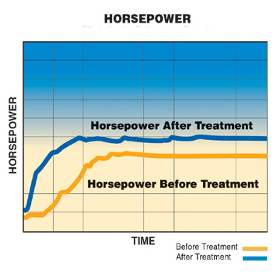

Average Percentage Improvement
Using 5201D
Horse Power | 8%
Torque | 10%
Diesel Consumption | 18.5%

N.B. The figures above are the averages from tests conducted on many types of engines in various applications using several types of diesel

Other Types of the 5201 Additives:

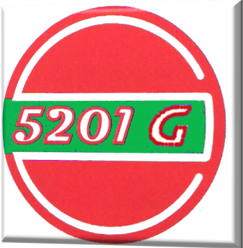

5201G

This is specially designed for local gasoline of any type (95 or 98). Its benefits are:

- Up to 35% less consumption
- Cleaner fuel system
- Smoother engine noise
- Better combustion
- Lower emissions

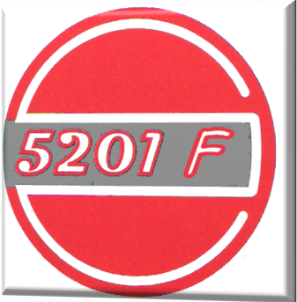
5201F

This is designed for fuel oil or heavy fuel applications. Tests are currently being carried out and it will be commercialized once sufficient backup data is gathered.

Material Safety Data Sheet

Section 1: Company Identification

Product Identifier: 5201D
Product Use: Diesel Additive
Manufacturer’s/Supplier’s Name: N.Y.E. sarl
Address: Kaline Center – Sin El Fil – Lebanon
Phone Numbers: +961 1 482435-6
Date MSDS Prepared: September 2008
MSDS Prepared By: N.Y.E. sarl

Section II: Statement of Hazardous Nature

This product is proprietary and has a confidential formula. It contains no highly flammable, caustic or acidic ingredients. It should not be hazardous when used and handled under normal conditions.

Section III: Hazards Identification

Health Rating: Slight | Skin Contact: May cause irritation
Flammability Rating: Slight | Eye Contact: May cause irritation
Reactivity Rating: Slight | Skin Absorption: No information Available
Contact Rating: Slight | Inhalation: May cause irritation
Storage Color: Light Green (general) | Ingestion: Can cause stomach upset

Section IV: First Aid Measures

Inhalation: remove to fresh air. Give oxygen if breathing is difficult. Seek medical attention if the situation deteriorates
Ingestion: drink large amounts of water and seek medical attention if large quantities are swallowed
Skin Contact: wash with plenty of water and seek medical attention if irritation persists
Eye Contact: wash thoroughly with plenty of running water. Seek medical attention if irritation persists

Section V: Fire Fighting Measures

Flammable: not under normal conditions | Flammable Conditions: contact with open flame
Means of Extinction: Dry Chemical, Carbon Dioxide, Alcohol Foam
Explosion: not explosive | Auto-ignition Temperature: N/A
Sensitivity to Impact: Not sensitive | Static Electricity: Not sensitive
Note: in the event of fire, please wear full protective clothing with self breathing apparatus and full face cover that operates under pressure.

Section VI: Accidental Release Measures

In case of spill or leak, ventilate the affected area. Wear protective equipment. Sweep and containerize for disposal. Vacuuming may be used.

Section VII: Handling and Storage

If received in bulk and not in the standard 20 liter containers, storage should be in closed dark containers preferably in the shades at ambient temperature. Transparent containers of any type are NOT recommended. Storing under direct sun light may cause the internal pressure to build up and burst the tank. Therefore, it is recommended to store in the shades.

Storage containers should be well sealed since leakage to the atmosphere for several hours may cause the dosage proportion to change which may lead to decrease the additive efficiency.

Section VIII: Physical Properties

Melting Point | -85 °C
Boiling point | >120 °C
Flash point | 65 °C
Specific Gravity | 0.84 – 0.88
Solubility in Diesel | 100% soluble
Stability | Highly stable

Section IX: Stability and Reactivity

Stability: Chemically Stable
Reactivity: May react with paint
Volatility: If subjected directly to the atmosphere for several hours, some ingredients will evaporate rendering the additive inefficient

Section X: Special Considerations

Store and ship in temperatures less than 45 °C
Whatever quantity that cannot be used or recycled should be well stored and disposed of in the appropriate and approved manner. It should be treated as chemical wastes
Always use gloves while handling. Do not inhale or ingest. Wash your hands thoroughly after handling

